# FUNCHEM/PCP - Semester I

**Tutorial: Coordination and Biocoordination Chemistry**

**What is a ligand?**

**A ligand is a molecule or ion that binds to a central metal atom or ion to form a coordination complex. The central metal atom or ion is typically a transition metal, and the ligands can be a variety of molecules or ions, including water, ammonia, chloride ions, and many others.**

**Ligands can be classified based on the number of donor atoms they have that can bind to the metal center. For example, a monodentate ligand has one donor atom, a bidentate ligand has two, and so on. The geometry of the coordination complex is determined by the number and arrangement of the ligands around the metal center.**

**Ligands play an important role in many biological processes, such as enzyme catalysis and metal ion transport. They are also used in many industrial applications, such as catalysis and materials science.**

**What does ‘denticity’ mean?**

“Denticity” is a term used in chemistry to describe the number of ligand donor atoms that are directly bonded to a central metal atom or ion in a coordination complex. It is a measure of the complexity of the coordination environment around the metal center.

For example, in a coordination complex with a denticity of 2, two donor atoms from the ligand are bonded to the metal center. If the denticity is 4, then four donor atoms are involved in the bonding. The denticity can be higher or lower depending on the number of donor atoms that are directly coordinating to the metal.

This concept is important in understanding the geometry, stability, and reactivity of coordination compounds. Different ligands can exhibit different denticities, and this can affect the overall properties of the complex. For instance, a bidentate ligand has two donor atoms that can bind to the metal, while a hexadentate ligand has six donor atoms that can bind, providing a very stable and often chelated structure around the metal ion.

**Draw the structures of (en) and the oxalate (ox) anion**

形状

**State which of the following are monodentate, bridging, bidentate, hexadentate:**



**H2O:monodentate、bridging**

**NH3: monodentate**

**H2NCH2CH2NH2(en): bidentate**

**Oxalate(ox): bidentate**

**EDTA4-: hexadentate**

**What is a chelating agent?**

**A chelating agent is a molecule or ion that can form multiple bonds with a single metal ion, typically through two or more donor atoms.**

**What is a chelate?**

**A chelate is a complex formed between a metal ion and a chelating agent. In this complex, the metal ion is bound to the chelating agent through multiple coordinate bonds, typically involving two or more donor atoms from the chelating agent. The term “chelate” comes from the Greek word “chele,” meaning “claw,” which describes how the chelating agent “grabs” the metal ion.**

**What is coordination number?**

**The coordination number of a metal ion in a complex is the number of ligand donor atoms that are directly bonded to the metal ion through coordinate bonds.**

**What is a Lewis acid and a Lewis base?**

A Lewis acid and a Lewis base are defined in terms of electron pair interactions according to the Lewis theory of acids and bases, which was proposed by the American chemist Gilbert N. Lewis in 1923. This theory is an extension of the Brønsted-Lowry acid-base theory and focuses on the transfer of electron pairs.

* **Lewis Acid**: A Lewis acid is a substance that can accept a pair of electrons. It is an electron-pair acceptor. In a chemical reaction, a Lewis acid will form a coordinate covalent bond with a Lewis base by accepting the electron pair from the base. Common examples of Lewis acids include hydrogen ions (H+), metal ions (such as Fe3+, Cu2+), and molecules with electron-deficient atoms (such as BF3, AlCl3).
* **Lewis Base**: A Lewis base is a substance that can donate a pair of electrons. It is an electron-pair donor. In a chemical reaction, a Lewis base will form a coordinate covalent bond with a Lewis acid by donating its electron pair to the acid. Common examples of Lewis bases include molecules with lone pairs of electrons (such as NH3, H2O, OH-), and anions (such as Cl-, CN-).

The interaction between a Lewis acid and a Lewis base is often referred to as a Lewis acid-base reaction or a coordinate covalent bond formation. This type of bonding is important in many chemical processes, including the formation of coordination compounds, where metal ions act as Lewis acids and ligands act as Lewis bases.

For example, in the reaction between ammonia (NH3) and boron trifluoride (BF3), ammonia acts as a Lewis base by donating its lone pair of electrons, and boron trifluoride acts as a Lewis acid by accepting the electron pair:

|  |  |
| --- | --- |
| **Coordination Number** | **Expected Geometry** |
| **2** | **Linear** |
| **4** | **Square planar/Tetrahedral** |
| **6** | **Octahedral** |

**State coordination number and oxidation state of metal ions in the following:**



**Chelation therapy is now used to treat a variety of conditions.**

(i) What is chelation therapy?

**Chelation therapy is the administration of chelating agents (by**

**intravenous infusions, intramuscular injections or oral administration) to**

**mobilise and remove unwanted or excess metal ions from the body.**



(ii) Shown opposite is the anion of Na2[Mg(EDTA)],   
a drug which may be used to treat calcium-containing   
plaques in arteries.

1. What is the oxidation state of the Mg ion?

and its coordination number?   
+2，6

1. What is the geometry around the metal?

Octahedral

1. What is the denticity of the EDTA ligand?  **6**
2. Explain briefly how Na2[Mg(EDTA)] may be used to treat these plaques and write an equation for the reaction involved.

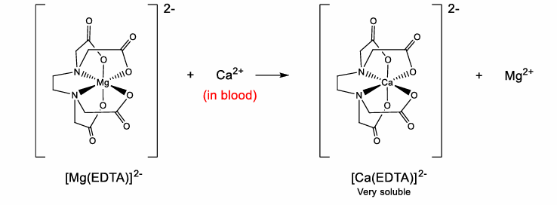

**Using your knowledge of crystal field theory ………….**

**What gives rise to d orbital splitting?**

**Draw a diagram to illustrate how d orbitals are split in an octahedral complex**

**What is the spectrochemical series?**

**What are weak field and strong field ligands?**

**Metal complexes and chelating agents are used to treat a wide variety of diseases.**

* 1. Meglumine antimoniate (proposed structure on right), which contains the N-methylglucamine ligand, is used for the treatment of Leishmaniasis.

In relation to this complex state the following:

Oxidation state of the metal ion -3

Coordination number of the metal ion 6

Geometry around metal ion 3

Ligand denticities:

(N-methylglucamine)

(hydroxide)

(ii) A patient with haemochromatosis is treated by subcutaneous administration of Desferal, structure below. This binds to and excretes excess iron(III).

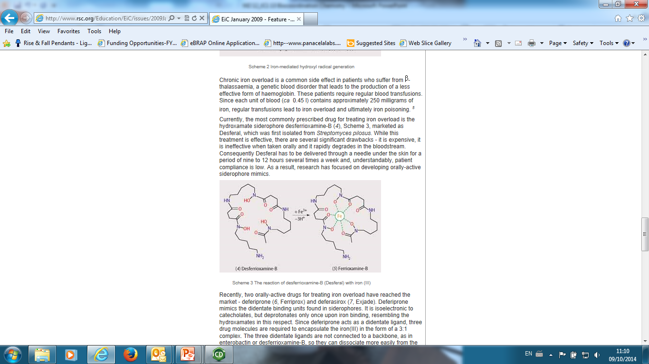

In the structure above circle the atoms that bind to iron(III).

Explain why the iron(III)-desferal complex is very stable.

五元环

Explain why the iron(III)-desferal complex is easily excreted from the body.

可溶于水

Give an example of another disorder in which Desferal is used – give an explanation as to why Desferal is used in this case.